

Know Your TX – Dissecting a Transaction

School: ............................................................................................................. Campus: ....................................................... Academic Year: ...................... Subject Name: ........................................................... Subject Code: ..........................

Semester: ............... Program: ........................................ Branch: ......................... Specialization: .......................... Date: .....................................

(Learning by Doing and Discovery)

**\* Coding Phase: Pseudo Code / Flow Chart / Algorithm**

ALGORITHM:

1. Open a blockchain explorer website like [https://etherscan.io](https://etherscan.io/).
2. Get a transaction hash (TX Hash) :

* from MetaMask (after sending ETH).
* Remix after deploying a smart contract.

1. Paste the TX Hash into the search bar of the Etherscan.
2. View transaction details such as:

* Sender Address (From)
* Receiver Address (To)
* Gas Used & Gas Price
* Block Number
* Timestamp
* Nonce (transaction count)
* Status (Success / Failed)

1. Observe how these details show the flow of the transaction on the blockchain.
2. Check if value (ETH) was transferred or if there is input data (for contract calls).
3. We understand that all transactions are permanent and traceable on blockchain.
4. End

# * Software Used:

1. MetaMask Wallet
2. Etherscan-[https://etherscan.io](https://etherscan.io/).
3. Brave Browser

1. **Setup MetaMask for Sepolia Testnet:**
   1. Open the **MetaMask** browser extension.
   2. Enable Sepolia Test Networkfrom the network list.
   3. 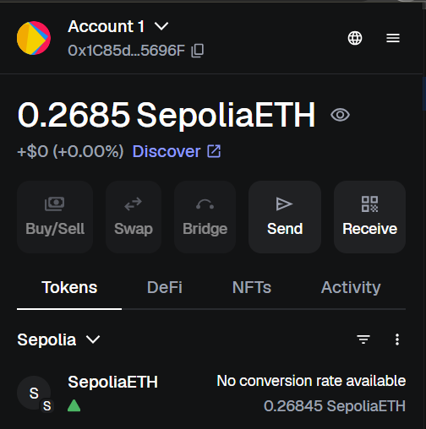Make sure We have some test ETHin your wallet.
   4. Get Test ETH:

* Copy the MetaMask account address.
* Visit a Sepolia Faucet and request free test ETH.
  1. **Verify Balance:**
* **Check our MetaMask Wallet.**
* You should now see test ETH in your Sepolia account.

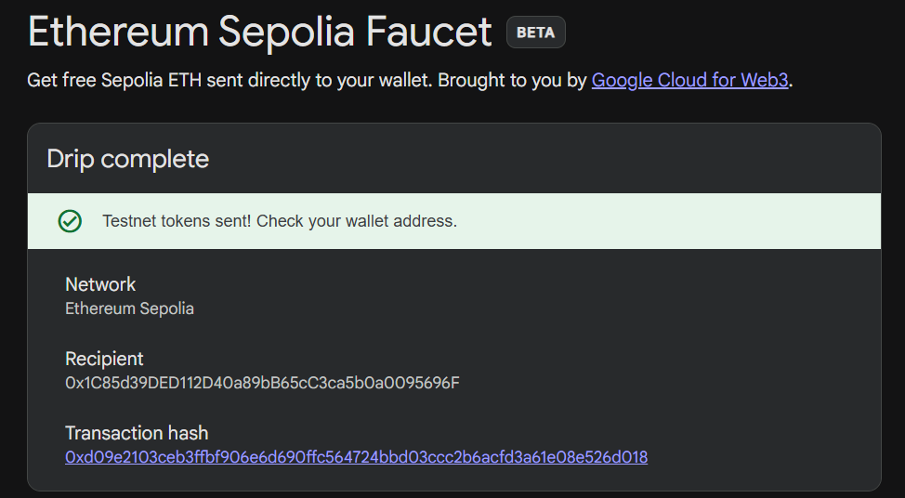

1. **Interact with a Smart Contract:** 
   1. Visit a platform like Remix IDEor any dApp interface.
   2. Deploy the Contract:

* Compile your Solidity smart contract in Remix IDE.
* Select Injected Provider (MetaMask) and deploy it to the Sepolia Testnet.
  1. Get Contract Address
* After deployment, copy the unique contract address generated.
  1. Use Functions
* Open the deployed contract panel in Remix.
* Call read functions (e.g., view stored data) → these don’t use gas.
* Call writes functions (e.g., update data) → these create a transaction and cost gas.
  1. Approve Transaction in MetaMask
* MetaMask will pop up with transaction details (gas fee, contract interaction).
* Confirm to execute the function.
  1. Verify on Etherscan:
* Copy the transaction hash.
* Paste it into Etherscan (Sepolia) to see details like sender, gas, status, and updated state.

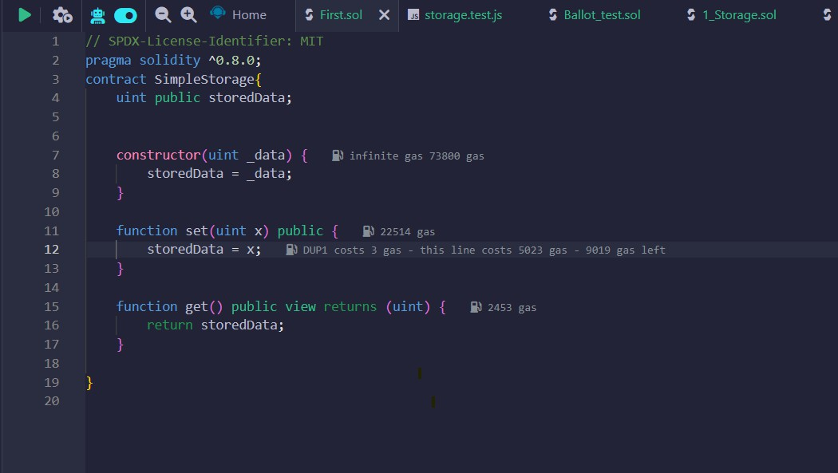

1. **Copy the Transaction Hash (TX Hash):**

* After sending ETH or deploying a contract, open **MetaMask / Remix**.
* Go to the **Transaction History**.
* Find your recent transaction.
* Copy the **Transaction Hash (TX Hash)** shown there.

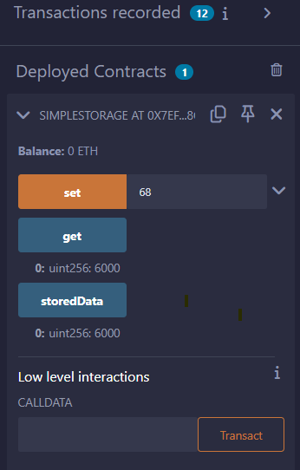

1. **Open Sepolia Etherscan:**

* Go to <https://sepolia.etherscan.io>.
* Paste your Transaction Hash (TX Hash) in the search bar.
* Press Enter to view transaction details.

(Ether Scan Contract Address Screen Short)

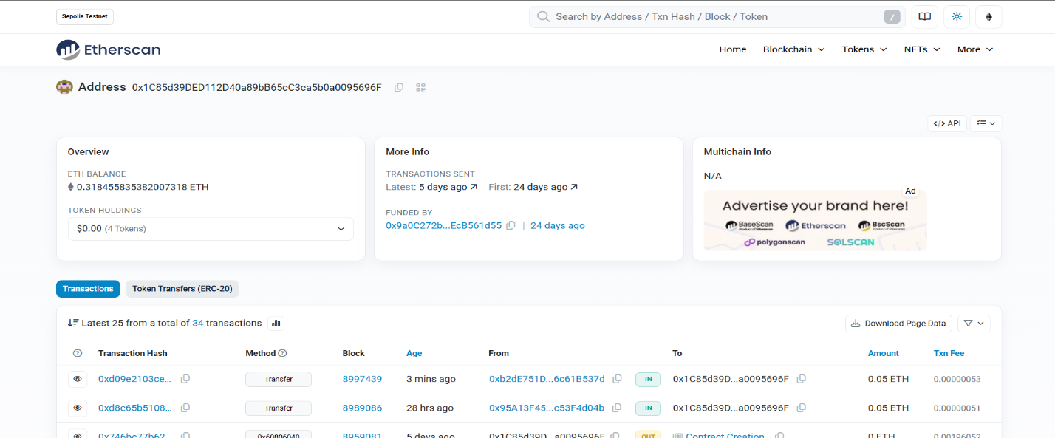

1. **Analyze the Transaction Details:**

On the transaction page, observe the things like **Status:** Success or Failure of the transaction, **Block Number:** The block that included your TX, **Timestamp:** Exact time and date of confirmation, **From & To Address:** Sender and receiver, **Value:** Amount of ETH transferred, **Transaction Fee:** Calculated as Gas Used × Gas Price, **Gas Price:** Fee per unit of gas set by the sender, **To (Contract):** If the transaction is a contract call, it shows the contract address.

## * Implementation Phase: Final Output (no error)

Applied and Action Learning

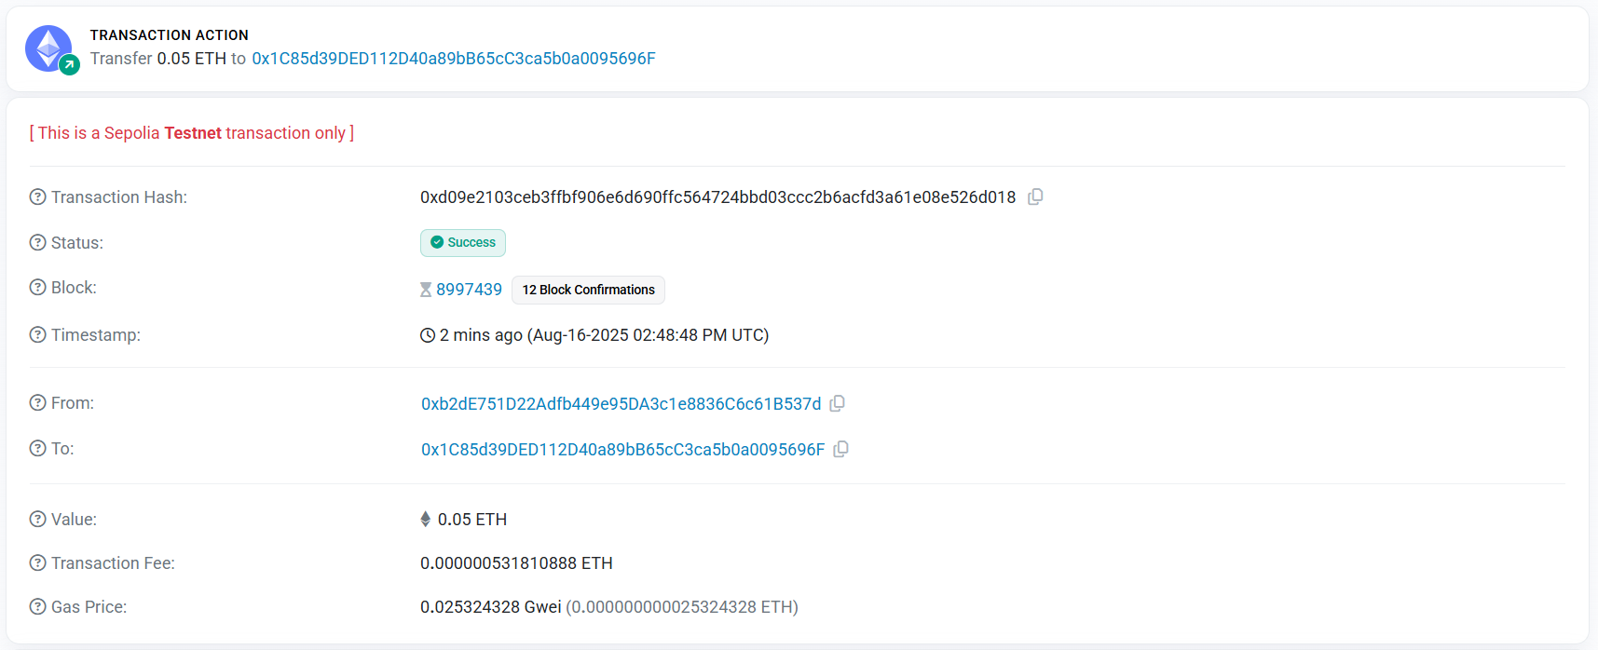

# Observation:

1. Each blockchain transaction has a unique Transaction Hash (TX Hash) used to track and verify it on the blockchain.
2. Important details like sender address, receiver address, gas used, block number, and status are publicly visible and transparent.
3. Transactions are immutable and once confirmed, they are permanently stored in the blockchain ledger.



|  |  |  |  |
| --- | --- | --- | --- |
| **Rubrics** |  |  |  |
| Concept | 10 |  |  |
| Planning and Execution/  Practical Simulation/ Programming | 10 |  |  |
| Result and Interpretation | 10 |  |  |
| Record of Applied and Action Learning | 10 |  |  |
| Viva | 10 |  |  |
| **Total** | **50** |  |  |

***Signature of the Student:***



***Signature of the Faculty:***